**DEVELOPE A MOBILE APPLICATION**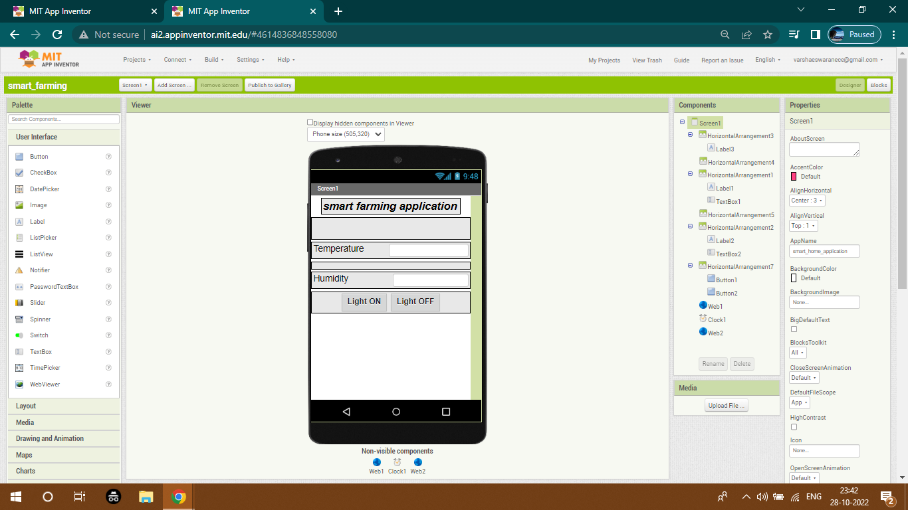

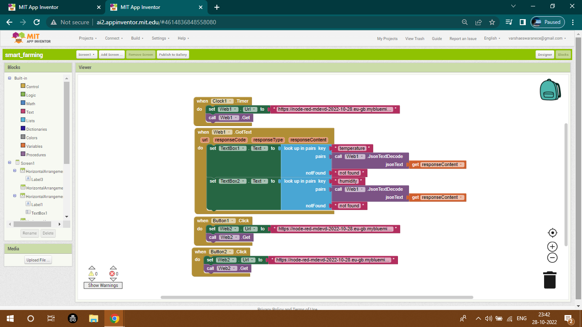

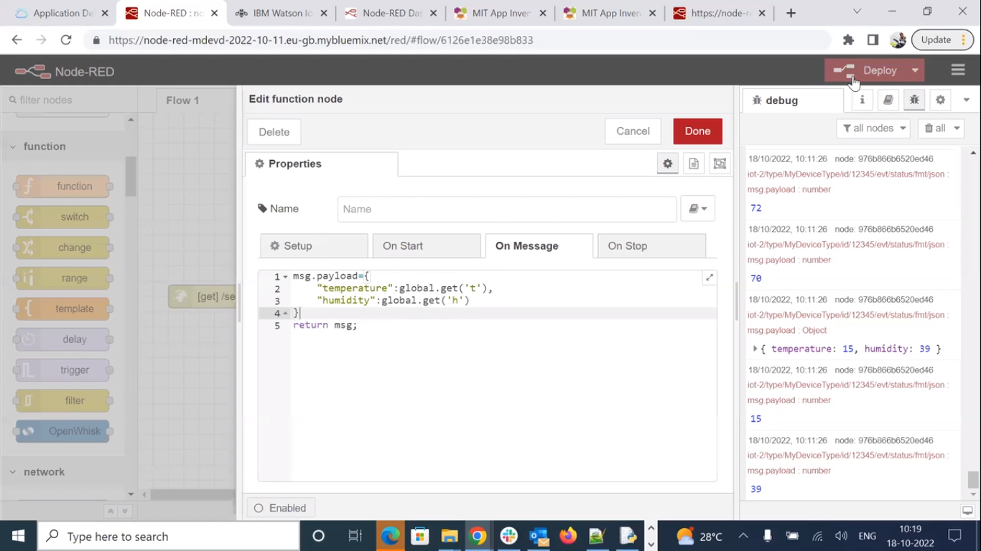

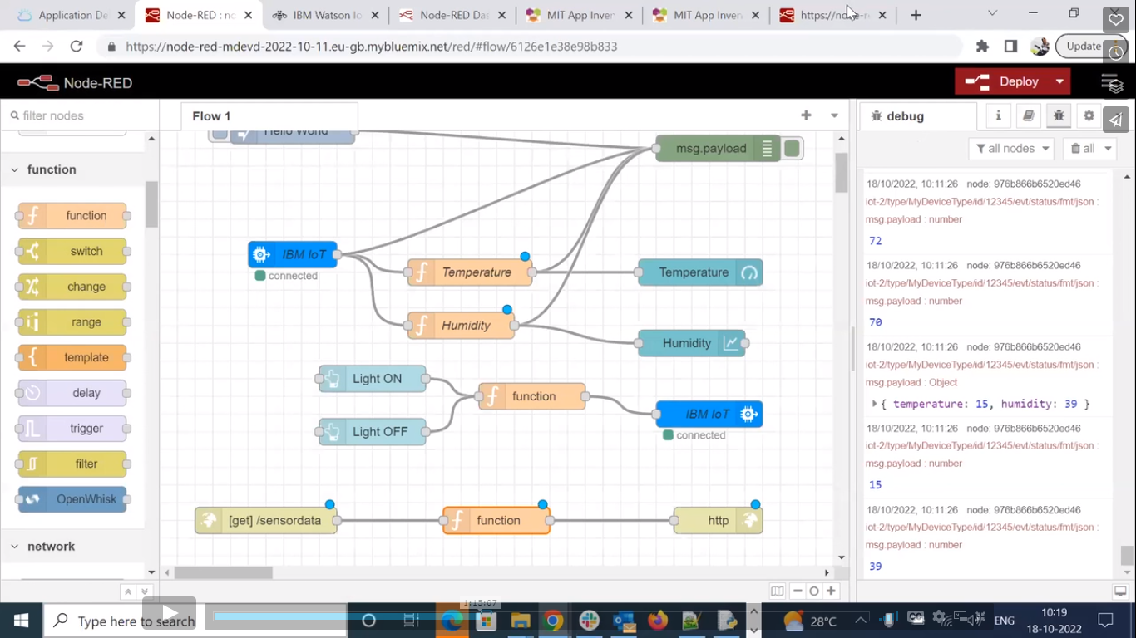

**BLOCK ALIGNMENT:**



**PROGRAM CODING:**

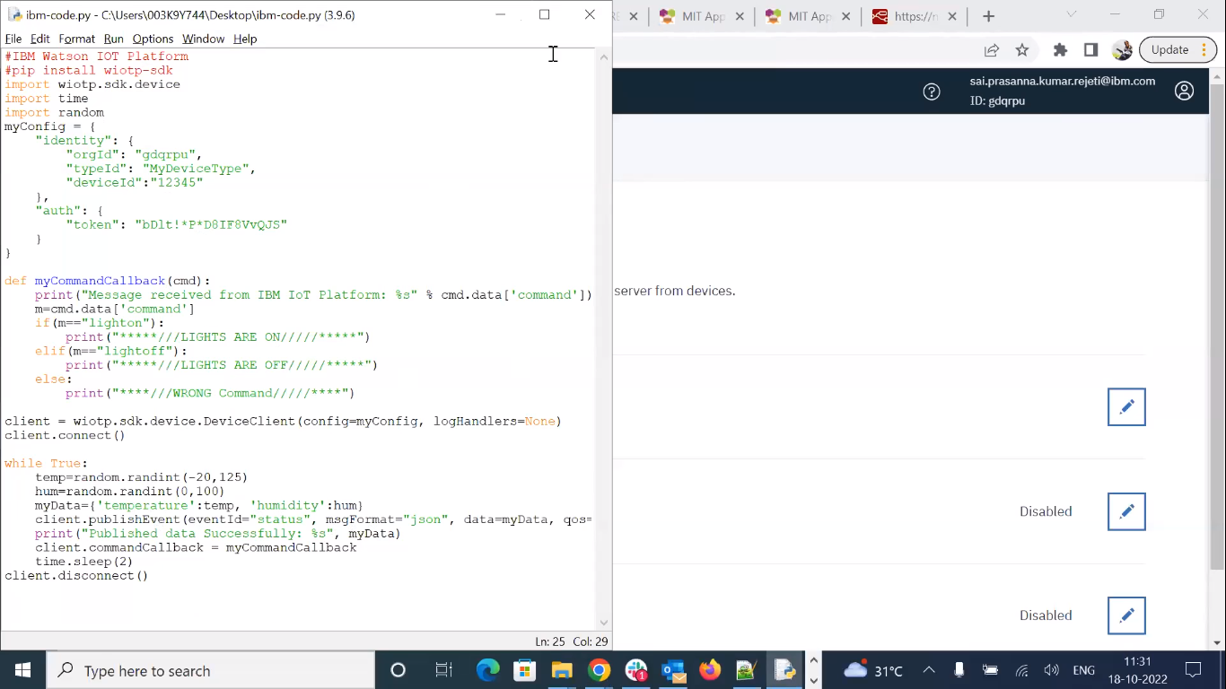

**OUTPUT:**

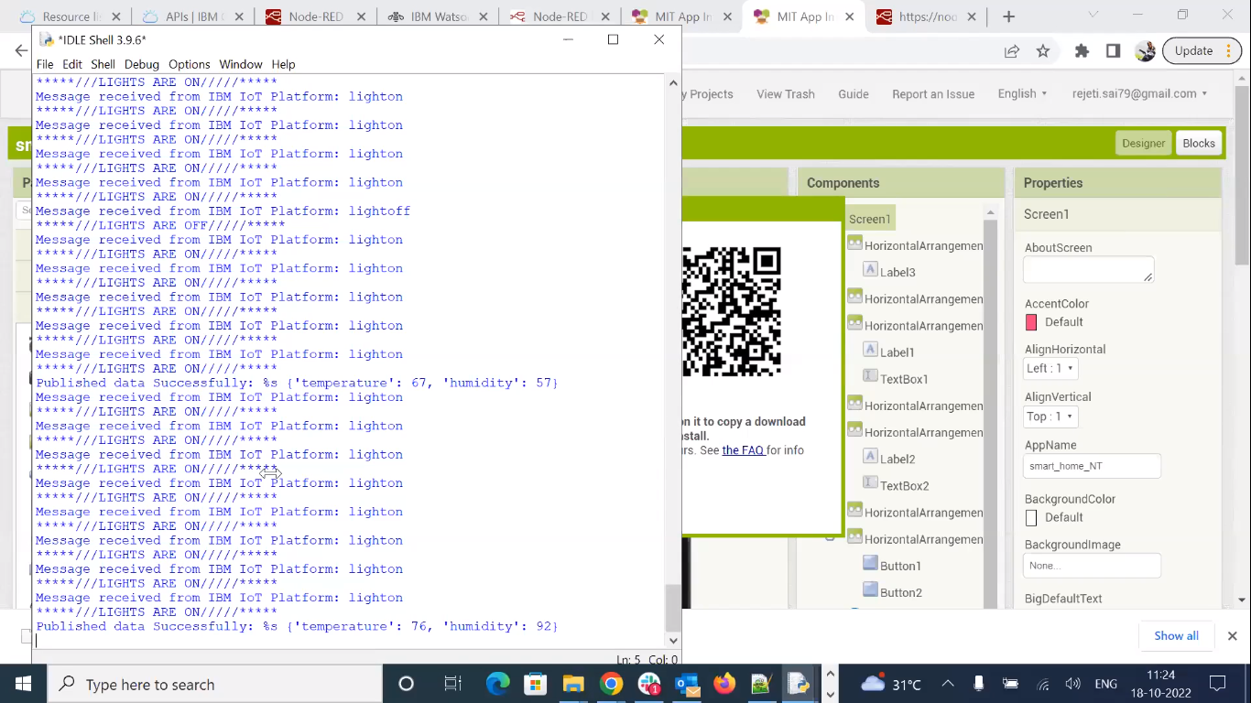

**USING WOKWI:**

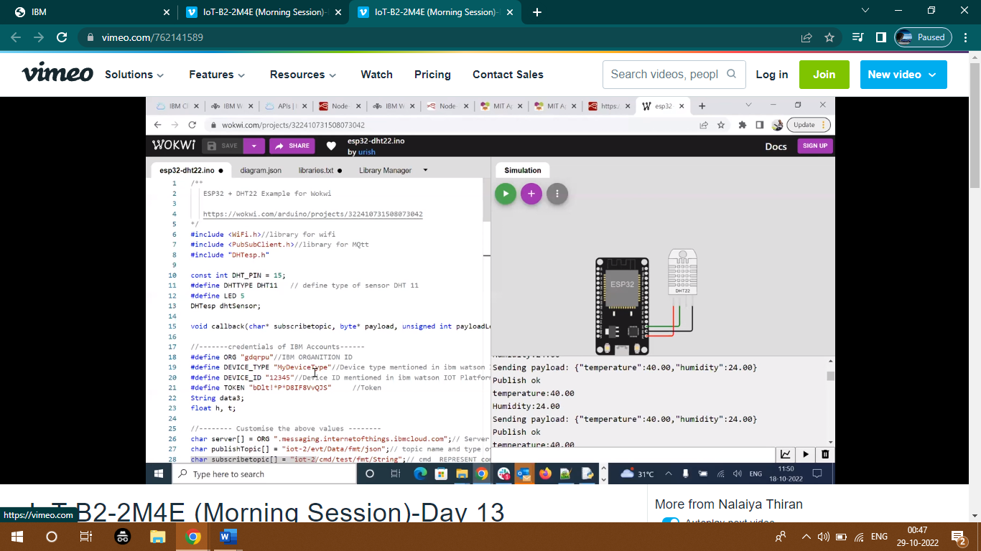

**VERIFY TEMPERATURE & HUMIDITY:**

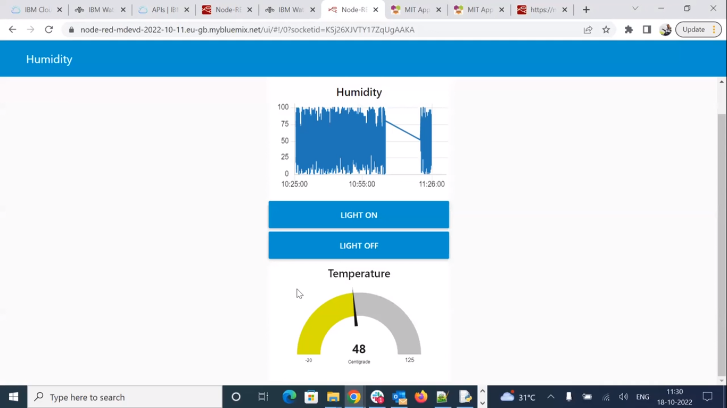

**URL LINK:**

**http://ai2.appinventor.mit.edu/b/37q48**